Case of alarm vocalization in a colony of Microtus guentheri (Danford & Alston, 1880) (Mammalia, Rodentia, Arvicolidae) from Southern Bulgaria

Ivan Pandourski

Institute of Biodiversity and Ecosystem Research, Bulgarian Academy of Sciences, 1, Tsar Osvoboditel Blvd., 1000 Sofia, Bulgaria, pandourski@gmail.com

Abstract. The main frequency characteristics of alarm vocalization in Guenter’s vole Microtus guentheri (Danford & Alston, 1880), expressed by single whistle signal are presented. The alarm call was recorded in a colony of Guenter’s vole in the valley of Byala reka River in Eastern Rhodopes Mountains, Sothern Bulgaria. The start of the call is explosive and marked frequency modulated, followed by uniform frequency plateau with narrow bandwidth of 2.3 KHz and maximum energy at 15.4 KHz.

Key words: Microtus, alarm call, spectrogram, Eastern Rhodopes Mountain.

Introduction
On encountering a predator, many rodent species emit potentially risky vocalizations known as alarm calls. The alarm vocalization is a phenomenon in a variety of ground-dwelling, social rodents and she is often species-specific and can therefore be used to distinguish between closely related species (Bradbury & Vehrencamp 1998; le Roux et al. 2002).
In Bulgaria the Guenter’s vole Microtus guentheri (Danford & Alston, 1880) inhabits mainly south-eastern part of the country and the population from Strandzha Mountain is described as M. guentheri strandzensis (Markov, 1960). The individuals from recently reported localities of the species in Eastern Rhodopes Mountains (Minkova 2004) differ cytogenetically from the population in Strandzha Mountain regarding the morphology and distribution of heterochromatin in the autosomes and sex chromosomes (Chassovnikarova et al. 2008). According to molecular phylogeny for six species of social voles, Kryštufek et al. (2009) consider M. guentheri as paraphyletic and consisting of two allopatric sibling species: M. guentheri (Syria, Israel) and M. hartingi Barrett-Hamilton, 1903 (Anatolia and the Balkans).
The goal of the present communication is to give the main frequency characteristics of alarm vocalization in Guenter’s vole in the Eastern Rhodope Mountains, expressed by single whistle signal, in regard to future comparative analysis of inter-population variability of alarm calls in social voles.

Material and Methods
The alarm call was recorded in a colony of Guenter’s vole in the valley of Byala reka River in Eastern Rhodopes, Sothern Bulgaria (41⁰ 22′ 11.68′′ N and 26⁰ 03′ 14.14′′ E, altitude 114 m a.s.l.) on 18.09.2005 at 8.10 PM using a portable Pettersson D240 ultrasound detector and audio-tape recorder Sony VM-D6C. The alarm vocalization was displayed in response to an observer walking among colony members. The computer analysis was performed using BatSound 3.1 software for Windows in time expansion (10 X). The frequency components of the call were measured from the Fast Fourie Transform (FFT) power spectrum, size 512, Hanning window. The following call parameters are considered: total call duration (ms), frequency with the most energy and highest and lowest frequencies (KHz) of the fundamental component respectively.
For the purpose of correct species determination, five individuals were captured by live traps type “Hartmann”, disposed among the studied colony (Popov, personal communication).

Results
The registered alarm call consists of a single phase with total duration of 167 ms (Fig. 1). The fundamental component has maximum energy at 15.4 KHz. More than three harmonics are expressed. The highest and the lowest frequencies are 17.2 KHz and 11.9 KHz respectively. The start of the call is explosive and marked frequency modulated, reaching the maximum frequency and bandwidth of 5.3 KHz. This part of the call has duration of approximately 9.3 ms. The rest of the spectrogram (157.7 ms) of the alarm whilst represents uniform frequency plateau with maximum energy at 15.4 KHz and narrow bandwidth of 2.3 KHz.

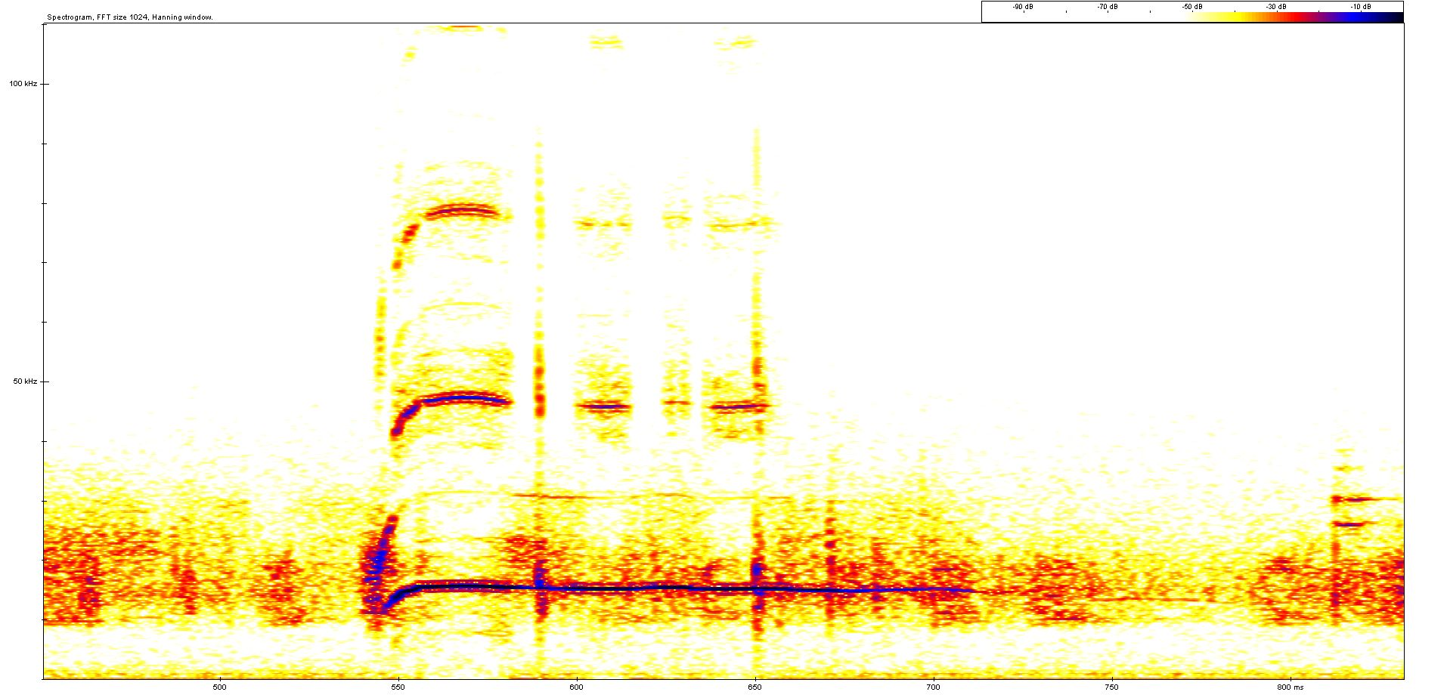

Fig. 1. Spectrogram of the alarm whilst of Guenter’s vole Microtus guentheri.

Discussion
Up to now the alarm call characteristics and display of vocalizations in many rodent species are still not well studied.
The fundamental frequency of the alarm calls in these mammals vary from audible (3-18 KHz) to ultrasonic (25-60 KHz) produced by infants of a number of myomorph rodent species (Mandelli & Sales 2004), but apparently the ultrasonic vocalizations have not been detected from other rodents. For the most of the North American voles species studied by Colvin (1973), the frequency of the fundamental component decreased with age.
In the present communication we give for the first the main characteristics of registered alarm vocalization in Guenter’s vole in response to the presence of human among colony members. According to other studies (le Roux et al. 2002) the rodents can emit variable alarm calls depending on microhabitat preferences. In this context we must expect individual and inter-population variability of alarm vocal activity in Guenter’s vole with relation to environmental factors.

References
Bradbury, J. & Vehrencamp, S. (1998) Principles of animal communication. M. A., Sinauer, Sunderland, 882 pp.
Chassovnikarova, T., Markov, G., Atanasov, N. & Dimitrov, H. (2008) Sex chromosome polymorphism in Bulgarian populations of Microtus guentheri (Danford & Alston, 1880). Journal of Natural History, 42 (5-8): 261-267.
Colvin, M. (1973) Analysis of acoustic structure and function in ultrasounds of neonatal Microtus. Behaviour, 44: 234-263.
Kryštufek, B., Bužan, E., Vohralík, V., Zareie, R. & Özkan, B. (2009) Mitochondrial cytochrome b sequence yields new insight into the speciation of social voles in south-west Asia. Biological Journal of the Linnean Society, 98 (1): 121-128.
le Roux, A., Jackson, T. & Cherry, M. (2002) Differences in alarm vocalizations of sympatric populations of the whistling rats, Parotomys brantsii and P. littledalei (Rodentia: Muridae). Journal of Zoology, London, 257: 189-194.
Mandelli, M.-J. & Sales, G. 2004. Ultrasonic vocalizations of infant Short-tailed field voles, Microtus agrestis. Journal of Mammology, 85 (2): 282-289.
Minkova, T. (2004) Small Mammals (Insectivora and Rodentia) of the Eastern Rhodopes (Bulgaria). In: Beron, P. & Popov, A. (Eds.), Biodiversity of Bulgaria. 2. Biodiversity of Eastern Rhodopes (Bulgaria and Greece). Pensoft & National Museum of Natural History, Sofia, pp. 895–906.

